- Download GnuCOBOL binaries from https://www.arnoldtrembley.com/GnuCOBOL.htm#binaries
- GC32-BDB-SP1-rename-7z-to-exe.7z
- Unzip to a folder: e.g., C:\Users\chenj\gnucobol
- Add GnuCOBOL bin folder to your PATH
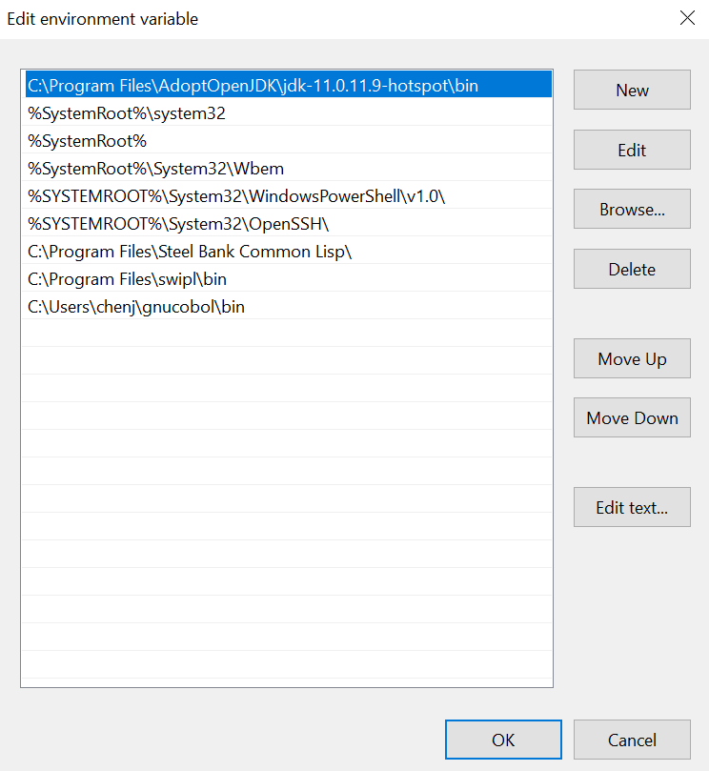
- Open cmd, type “cobc -v”.
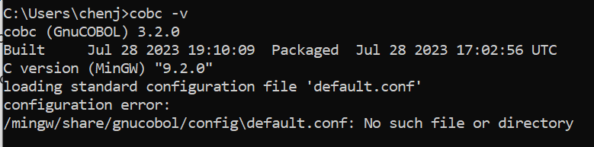
- Install Bitlang COBOL Extension. Search COBOL by Bitlang.
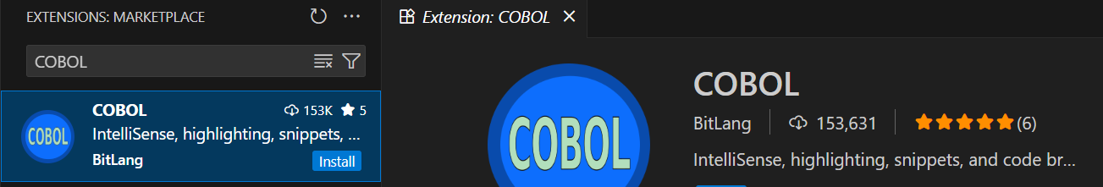
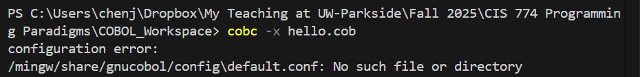
To fix this issue:
- Create the following folders exactly: C:\mingw\share\gnucobol\config
- Go to your extracted GnuCOBOL binaries folder, find: C:\Users\chenj\gnucobol\config
- Copy all files from that folder (default.conf, cobconfig, etc.) into the new folder
- Type “.\hello.exe”

